

***Project Documentation Manual* [ *School Computer Lab Network* ]**



***GROUP # 3***

***ZULAIKHA LIAQAT (089357)***



***CONTENT:***

1. **Introduction *Page # 4***
2. **Project Overview** *5*
3. **Objectives** *6*
4. **Scope** 7
5. **Methodology** 7
6. **System Architecture** 9
7. **Implementation Details** 9



1. **Results and Analysis** 14



1. **Conclusion** 16

# Introduction:

The aim of school’s computer lab network is to setup a secure and functional network so that we can manage the educational activities of students and teachers. Here we will focuses on the setting of network which includes devices, printers and a server.

This network is **significant** because it,

* Provides hands on experience in network planning.
* Implementation



* And troubleshooting.

The **technologies** or **protocols** that we have used are as follows



* ACL filters.
* ARP.
* DHCP.
* FTP.
* HTTP.
* HTTPs.
* ICMP.
* IPSec.
* TCP.

**Essentials:**

Because it is a school’s network not different networks so the essentials of the network are.

* Firstly, We will make the network DHCP, a protocol which assigns automatically IPs to all devices.
* Then, FTP which is used to make files transfer on the network, we can upload and download to and from the server.
* Firewall security, in which we block the **ICMP** and allow the **IP** as **URL.**
* And at the end, edit the **Access Control List**.

# Project Overview: o Purposes:



* The purpose of this network is to create a secure and efficient network lab within a school environment.



* Identify this network with students, its major use, scope and devices so they can explore advance skills.
* By planning the layout, assigning IPs, setting the shared resources such as printer, implementing security protocol such as ACL and Firewall and ensuring the communication between devices, a reliable network will be ready.
* Students can recognize that how different devices connect and how they communicate with each other.

o **Outcomes:**

▪ By planning the layout, assigning IPs, setting the shared resources such as printer, implementing security protocol such as ACL and Firewall and ensuring the communication between devices, a reliable network will be ready to send and receive messages and many other purposes.



# Objectives:



* Design and implement a structured lab layout with defined roles for computers, printer and server.
* Assigning DHCP configuration based on network requirement such as printers and server.
* To connect computers at one place.
* Connection should permanent, fast and efficient.
* To share files and hardware such as printer.
* To own and control by one person or organization such as school.
* Implement security measures such as Firewall and ACL to protect the network.
* And at the end verify successful communication between devices to ensure network functionality.

# Scope:



The project includes planning, designing, implementing, and testing the school computer lab network. It includes setting up hardware, configuring software, establishing connections, and ensuring network security. Excluded aspects involve advanced networking protocols beyond the scope of this project.



# Methodology:

Here we will utilize the knowledge of Firewall, FTP, DHCP and ACL.

* Firewall: We cannot ping the Server, only can access the network from website of server.
* FTP: File transfer protocol used to upload and download files to and from the server.

▪ Commands of FTP are delete, dir, get, rid, help, passive, quit, pwd and rename.

* DHCP: For dynamic IP address allocate to devices.



* ACL: Access control list to restrict access to sensitive resources and services.



# System Architecture:

## Step 2:

|  |  |  |
| --- | --- | --- |
| **S.NO** | DEVICES | MODEL-NAME |
| 1. | PC | PC |
| 2. | Server | Server-PT |
| 3. | Printer | Printer-PT |
| 4. | Switch | 2960-24TT |

o Connect all PCs, Server and Printers with **central Switch** by using copperstraight cable.



## Step 3:



o Assign static IP addresses to Server and Printers.

|  |  |
| --- | --- |
| **Device** | IP address |
| Server | 192.168.0.1 |
| Printer1 | 192.168.0.2 |
| Printer2 | 192.168.0.3 |

## Step 4:

Make the server a DHCP server.

* Go to the services of server and then click on the **DHCP.**
* Then, **on** the services.

* 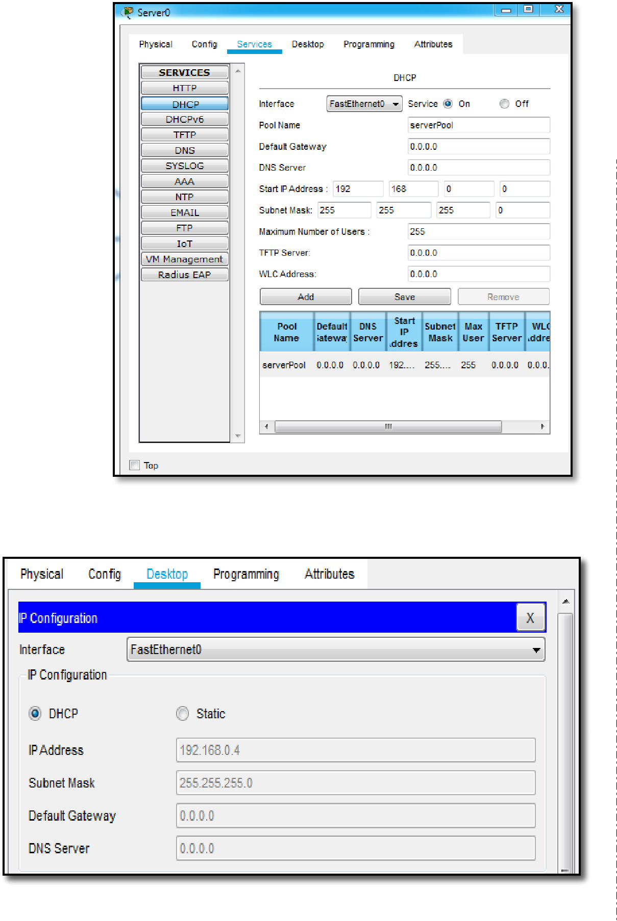Add the gateway, starting IP address and maximum number of user and save.

## Step 5:



* Go to the IP configuration of Pc.
* Click on the **DHCP.**
* **Server** gives IP address.

## Step 6:

Make the server a FILE server.

* Go to the services of server and then click on the **FTP.**
* Then, **on** the services.
* Add **username** and **password.** o Click on the **read, write, rename, delete** and **list** option and **add**.

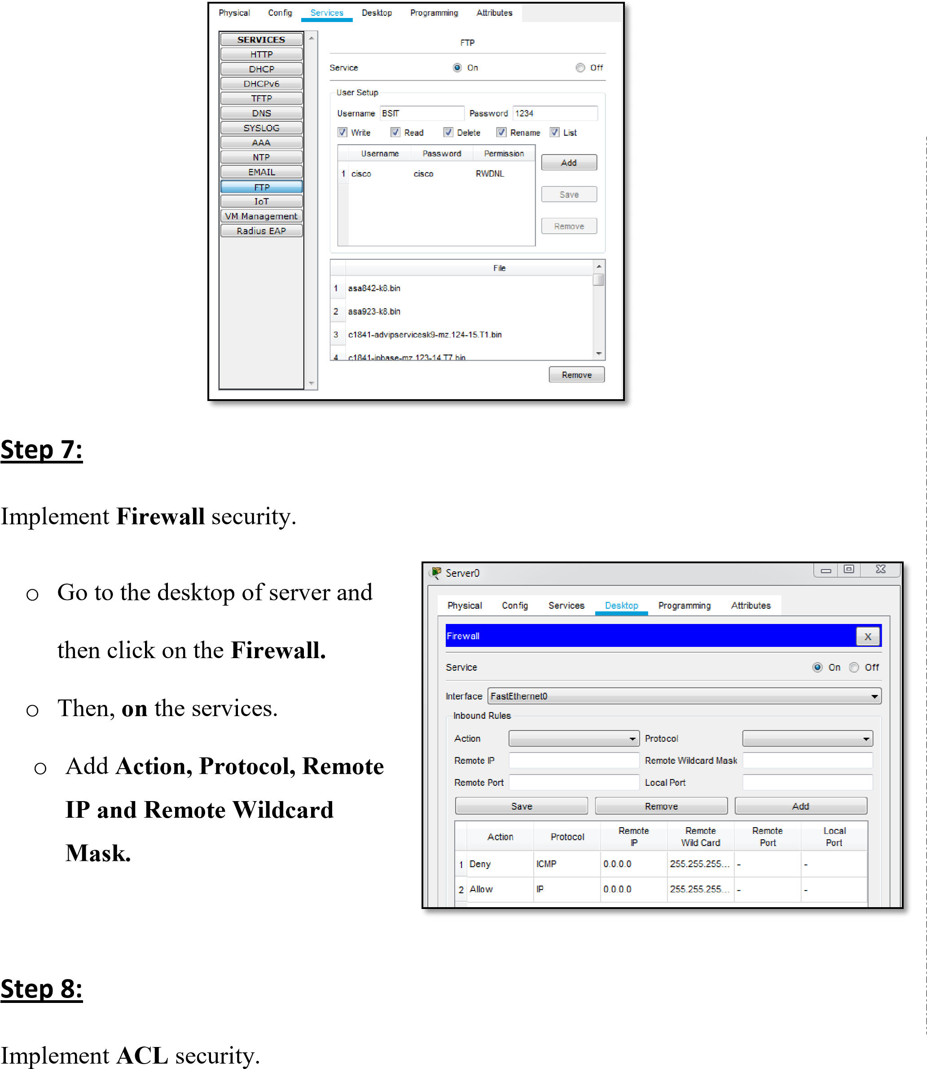



* Go to the Simulation and then click on the **Edit ACL Filters.**
* Then, **click** on the protocols which we use in project from **IPv4.**
  + **DHCP :** For DHCP IP address for Pc.
  + **APR :** For Static IP address for server and printers.
  + **ICMP :** We use this protocol for ping.
* Then, **click** on the protocols which we use in project from **IPv4.**
  + **ACL Filter :** used to control traffic flow and enforce security policies.
  + **FTP :** For File transfer.



* + **HTTP | HTTPS :** We use this protocol for making website for web server.



* + **TCP | UDP :** This protocol are used for data transmission between devices.

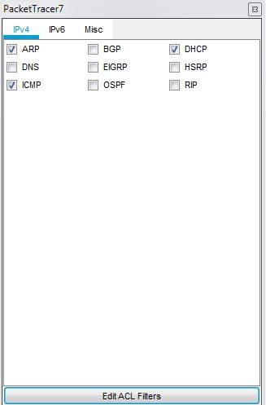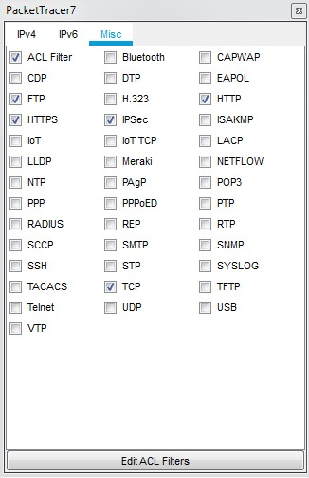

**Implementation is done.**

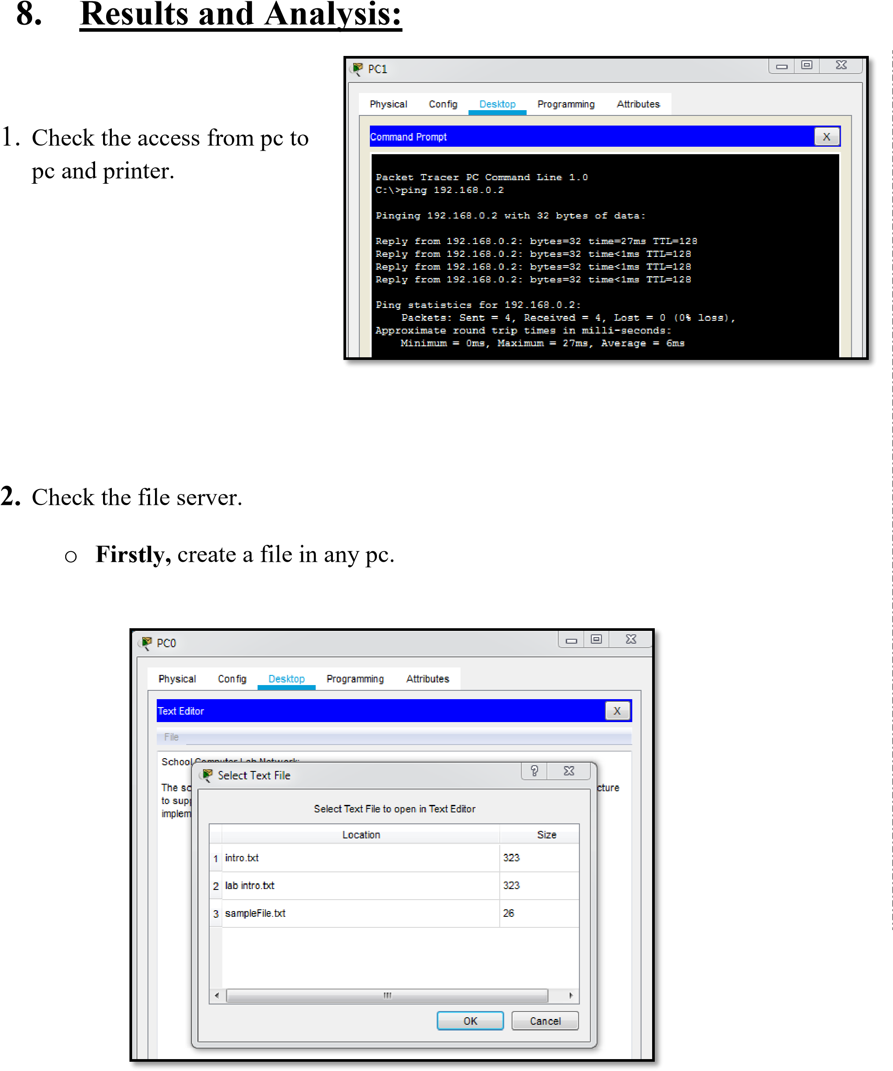



|  |  |  |
| --- | --- | --- |
| P a g e | **15**    o **Go** to the command prompt and then type **ftp [ Server IP ] then,** add **username, password.**                We can **upload** file to server by the command **put [ file name.txt ]** and download file from server by using command **get [ file name.txt ] etc.**  **3.** Check the **firewall security** o **Ping** the server from any Pc, but there is 100% lost because of security. | | |
|  |  |  |

